Grade 1 Burton Ettinger School Supply List 2025-2026
**Please do not label your child’s supplies as we will be sharing all year**
We have added pictures of the items that last the longest in the classroom.
2 packages - Crayola crayons 24 pack | 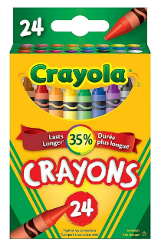 | 2 packages -  Washable Crayola markers 10 pack | 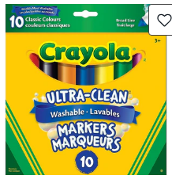
2 packages of 12-  Blue Staedtler pencils (pre-sharpened) | 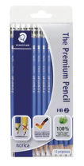 | 4 - white erasers (please remove plastic) | 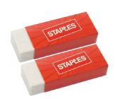
2 packages -  whiteboard markers 4 pack | 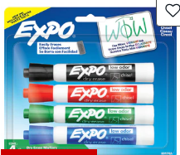 | 1 - pair of blunt tip scissors | 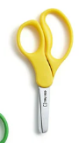
6 - Elmer’s glue sticks (20 grams) | 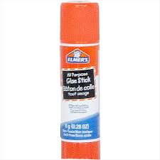 | 1 - 72 page ½ lines Yellow Hilroy scribbler | 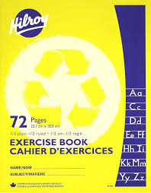
1 - ½ interlined 72 page Green Hilroy scribbler | 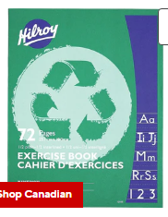 | 1- Sharpies permanent markers (fine tip) | 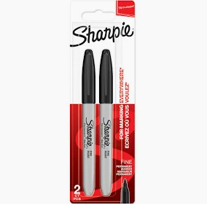
2 plastic with pockets folders  1 each of red and blue | 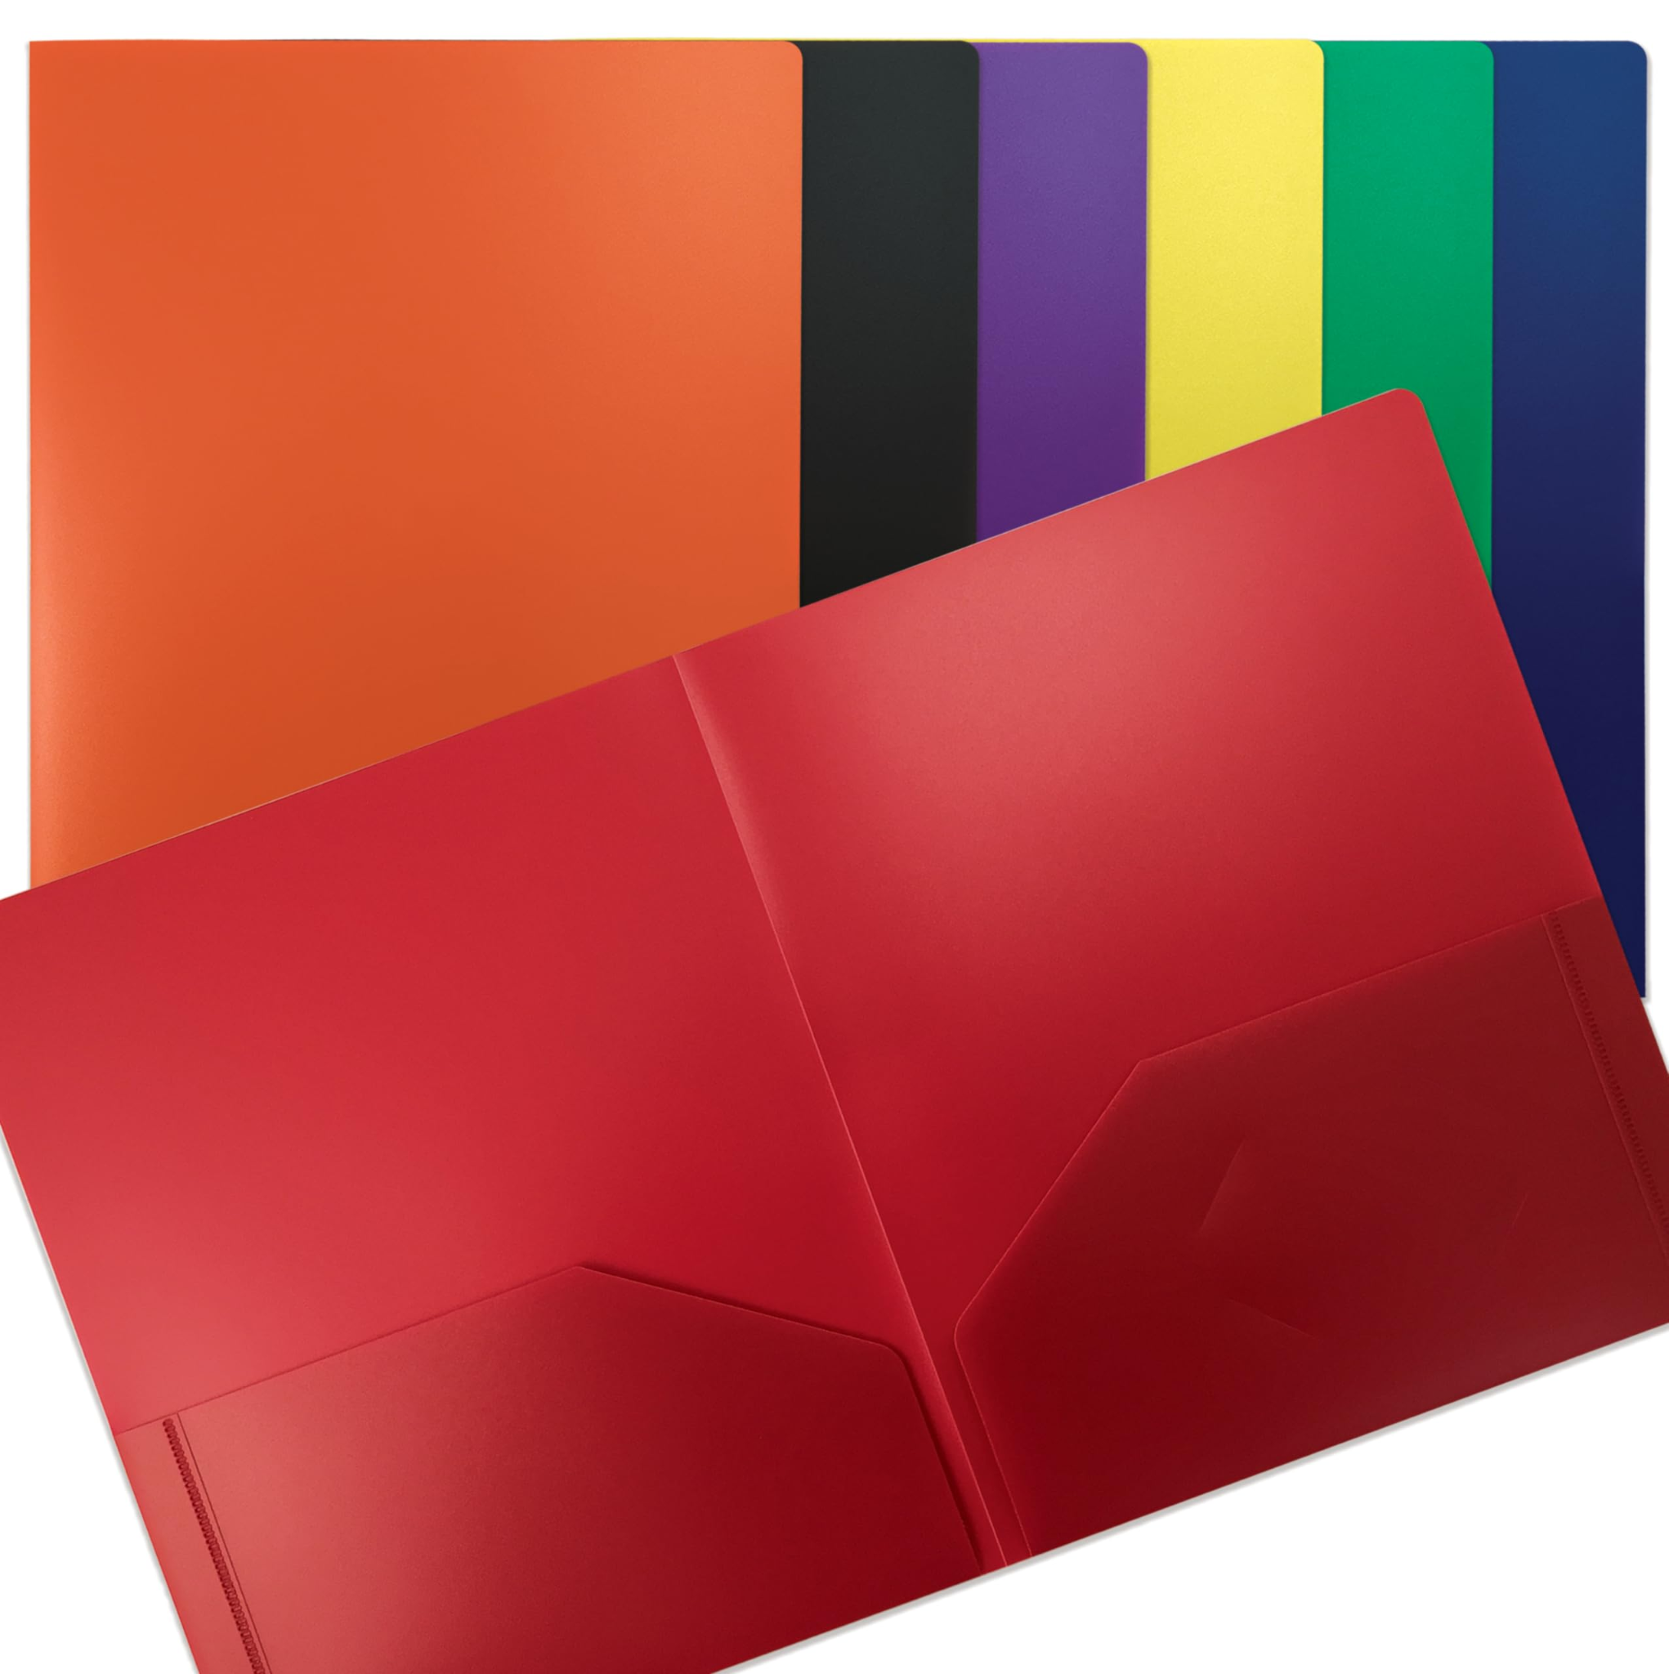 | 1 duotang with pockets | 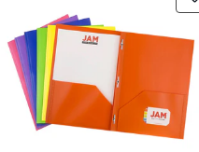
1 container of Play-doh | 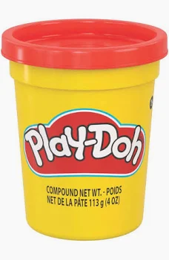 | 1 pair indoor sneakers (labeled) Children must be able to change shoes independently. | 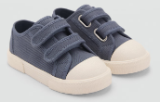
Deck of cards | 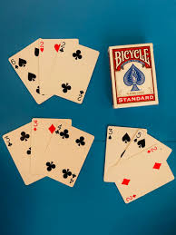 | Leak Proof Reusable water bottle
Students will also need a backpack labeled with their name. Please ensure the backpack is large enough for their lunch box and books.

Optional items to donate to the classroom:
Tissues Ziplock bags (Large) Plastic sheet protectors baby wipes

