Primary English and Primary French Immersion
School Supply List
We have added pictures of the items that last the longest in the classroom.

2 packages - Crayola crayons 24 pack | 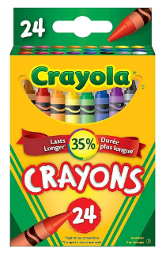 | 2 packages -  Washable Crayola markers 10 pack | 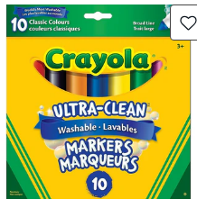
1 package -  Blue Staedtler pencils | 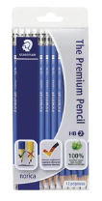 | 2 - white erasers | 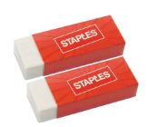
1 package -  whiteboard markers 4 pack | 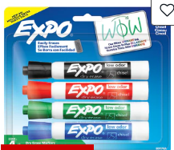 | 1- pair of blunt tip scissors | 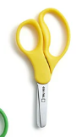
4 - glue sticks  20 grams | 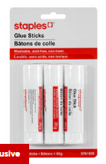 | 1 - plain 72 page Blue Hilroy scribbler | 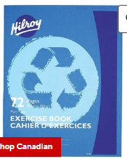
1 - ½ interlined 72 page Green Hilroy scribbler | 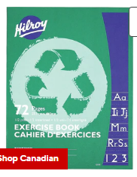 | 1 package - Hilroy exercise book  4 pack | 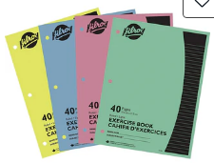
1- plastic  3 hole  duotang | 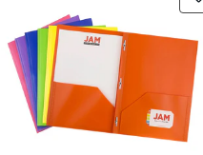 | 1- plastic pocket folder | 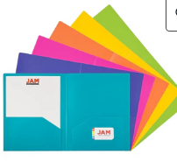
2 containers of Play-doh | 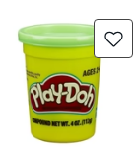 | Velcro sneakers (to be left at school for the year) | 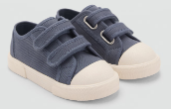

Optional Items:
Large ziploc bags
Package of golf pencils
Kleenex
baby wipes

