 | Respectful | Responsible | Safe
 | We honor and respect others, ourselves, and the spaces we share. We listen to adults and follow expectations to create a positive environment for everyone. | We do what’s right, even when no one is watching. We build trust in our school by being honest and taking ownership of our words and actions. | We stay safe by following expectations, so everyone feels comfortable and cared for at school. We do our best to contribute positively to our school community.
Learning Environments  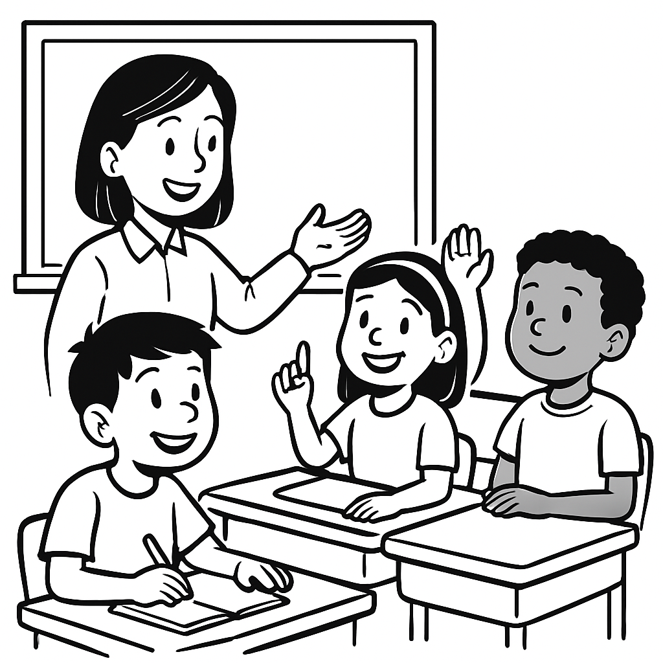 | - Quiet voices, listening ears  - Use polite language and manners  - Stay in your learning space  - Allow others to learn | - Do your best learning and remember to keep trying!  - Take care of learning materials  - Participate in your learning  - Clean up after yourself | - Move carefully, watch for others in the room  - Put learning items away  - Use materials appropriately  - Use an appropriate voice level
Transitions  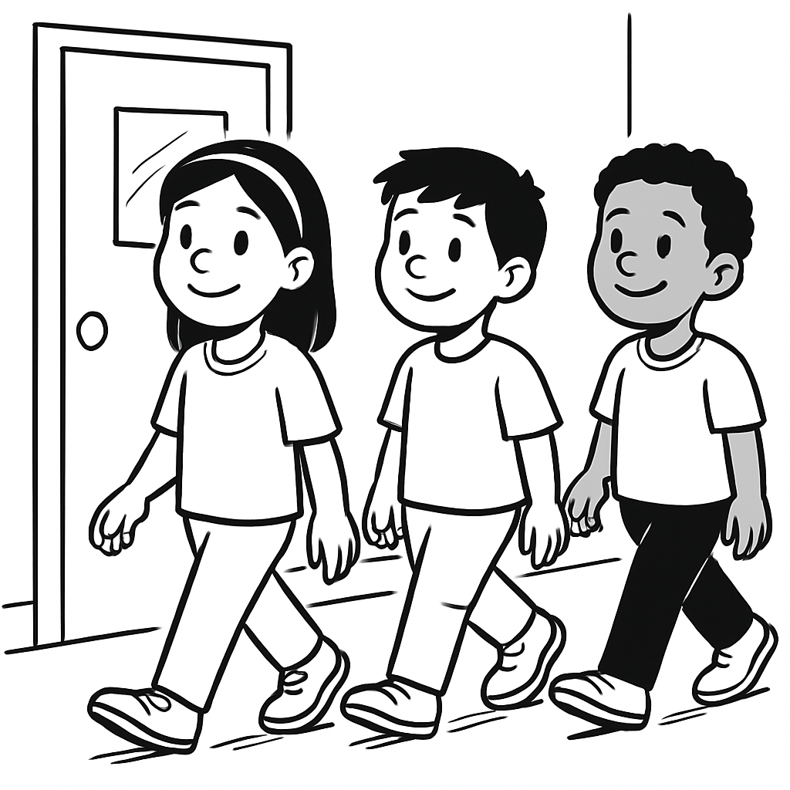 | - Use a quiet voice and walk calmly to avoid disturbing others  - Keep to the right and walk in a single line  Respect personal space—no pushing, shoving, or crowding | - Be aware of your surroundings  - Keep hook space in the hallway clean  - Ask before going into the hallway and go directly to your destination | - Always walk facing forward—no skipping steps  - Use friendly feet—no running or jumping  - Always keep your hands to yourself  - Keep the hallways clear so everyone can move safely
Shared Spaces  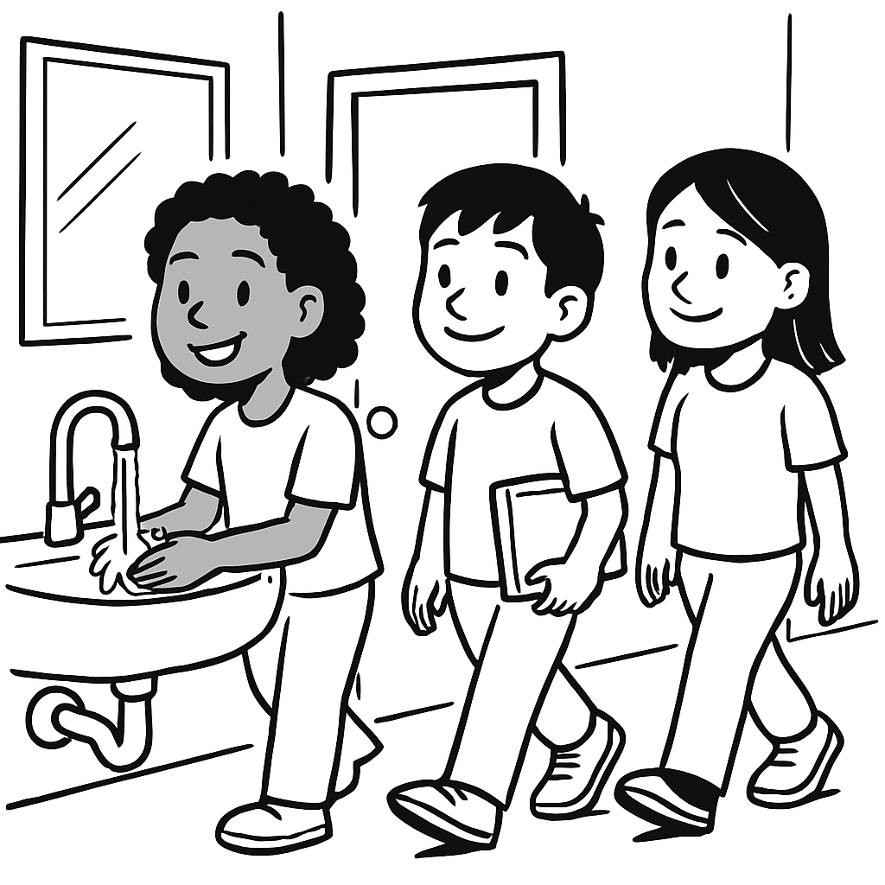 | - Keep clean  - Wait your turn  - Give others personal space  - Respect the privacy of others | - Use for its intended purpose and return to class  - Use only the supplies you need  - Report problems to an adult  - Tidy up the area - leave it cleaner than you found it | - Give others privacy  - Tell an adult if something is broken or unsafe  - Wash your hands with soap and water
Lunch & Snack  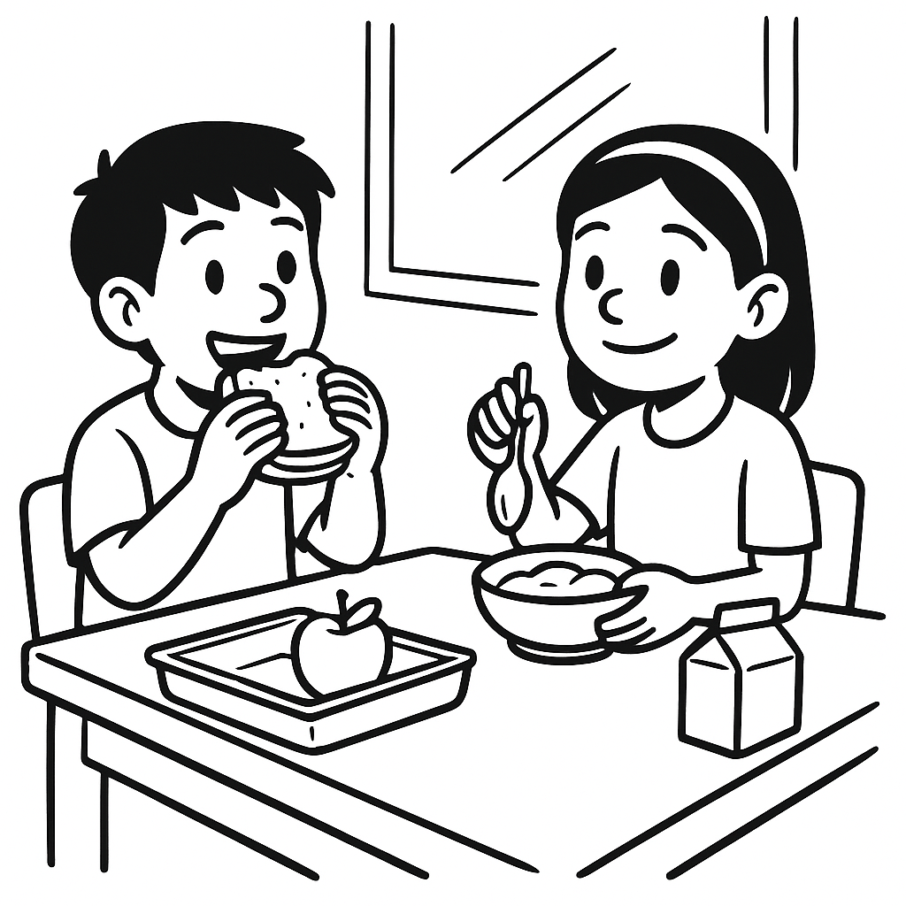 | - Ask an adult to leave the room  - Clean up your eating space when finished eating  - Use kind words and table manners  - Listen to lunchtime helpers and adults  - Keep your hands, feet, and food to yourself | - Clean up after yourself  - Stay seated while eating  - Only eat the food that was made for you  - Use appropriate bins for organics, garbage, recyclables | - Listen to lunch monitors instructions  - Use respectful voice volume  - Keep food and drinks in your space  - Let an adult know if there’s a spill or problem
Playground/Outside  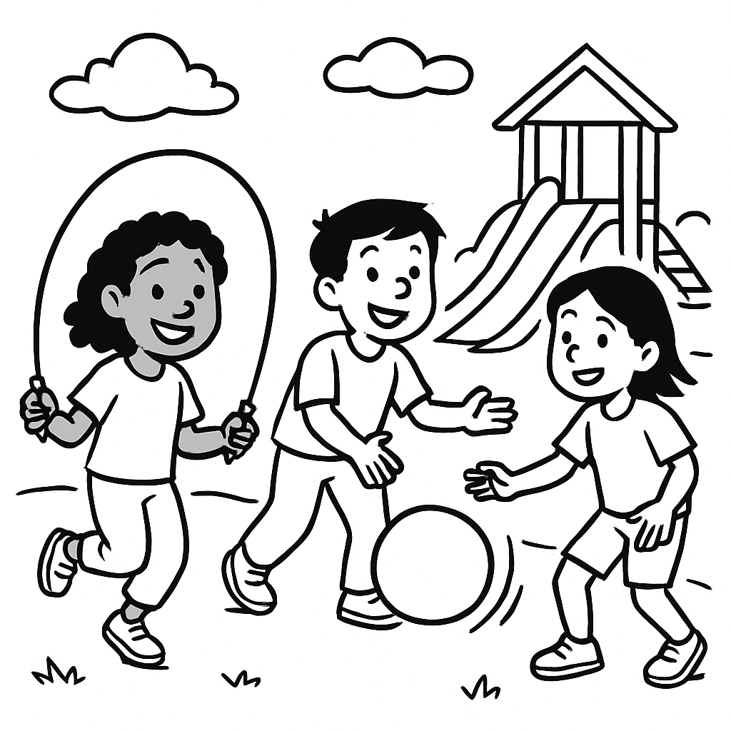  0 | - Put equipment back where it belongs  - Play stops at the bell; quickly line up when the bell rings  - Listen when someone says “no”  - Use kind words and actions  - Follow game rules and play fairly: take turns  - Listen to adults and peers | - Use equipment properly  - Clean up and return equipment after use  - Solve small problems with words or ask for help  - Stay in your assigned area | - If someone is hurt find an adult  - Keep hands, feet, and body to yourself  - Be aware of your surroundings  - Use equipment the way it was meant to be used
Emotions | - Use respectful communications (words and tone)  - Use “ I ” statements (I need, I feel) | - Ask for a break  - Take deep breaths  - Use calming strategies | - Look for adult support  - Walk to a safe space

